Replicate the EBS using snapshot

Create a EC2 instance wioth ev erything default

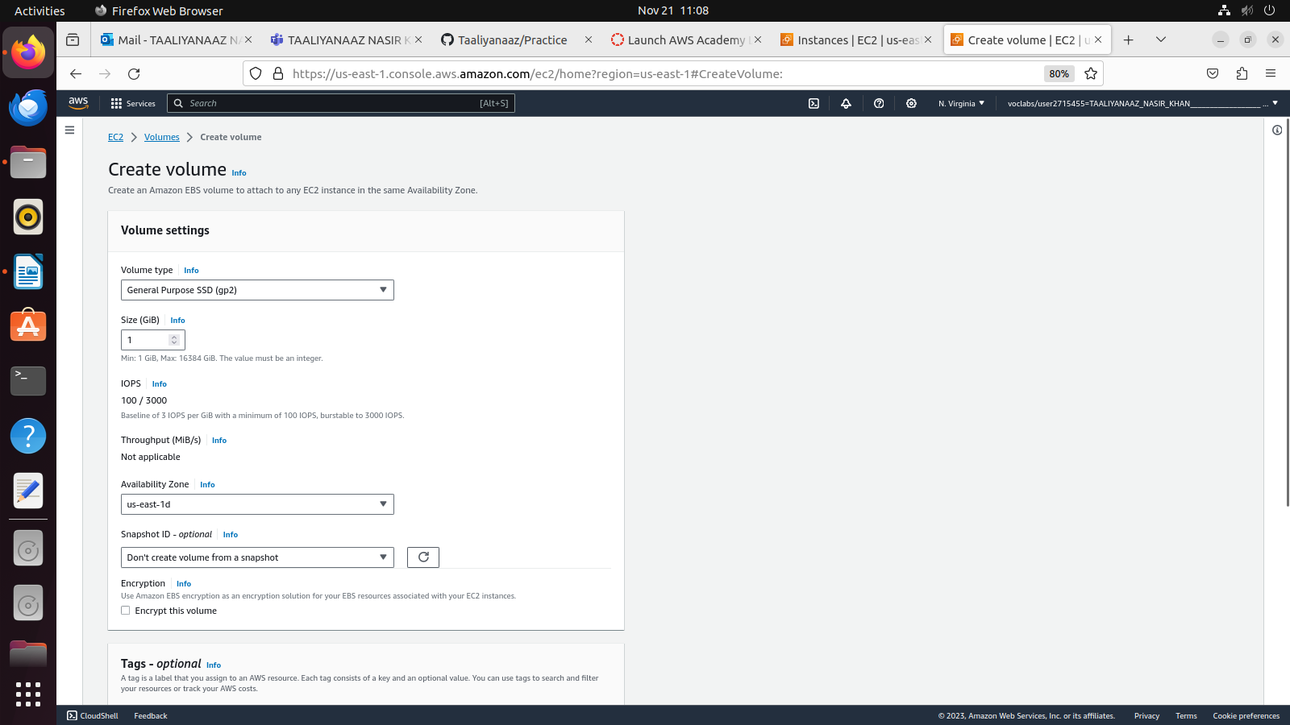
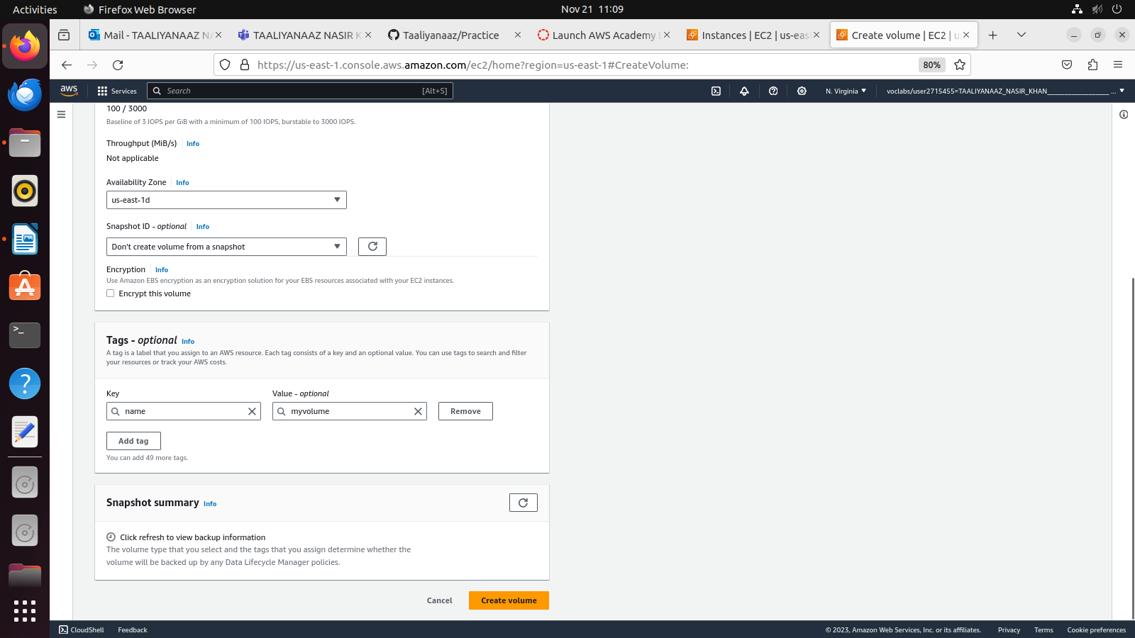
Availability zone should be same as EC2 instance
click on crteate volume

Once the volume is created, click on the volume and check its volume state: Available
Go to actions and click on attach volume

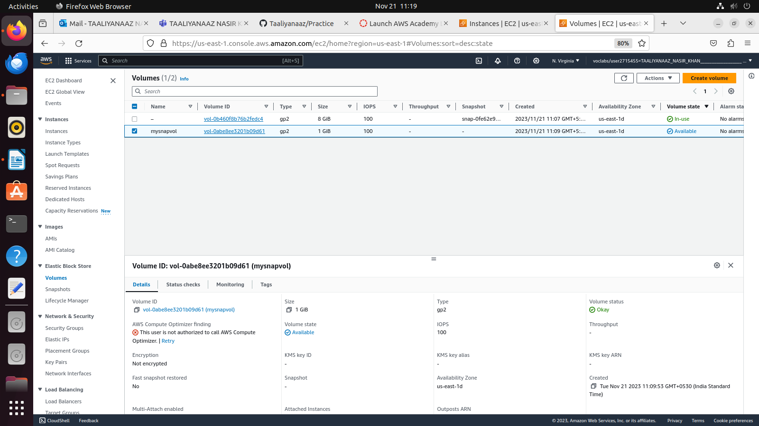
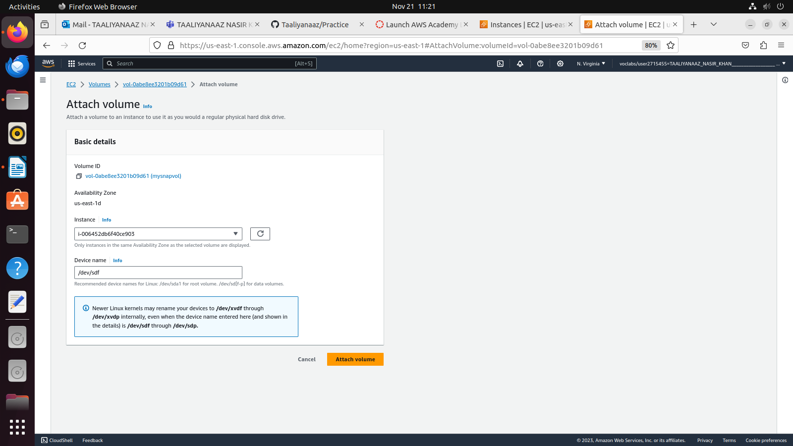
Click on Attach Volume

The state will chnage from Available to in-use after adding the instance
Select instance name from the drop down and the device name: /dev/sdf
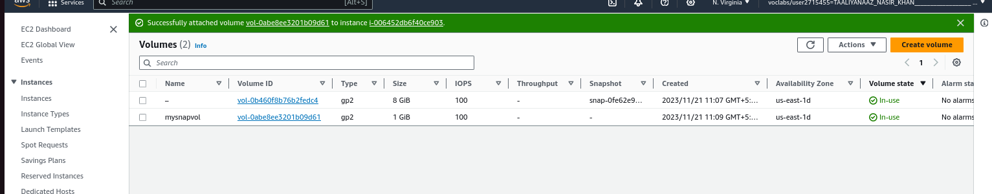
-> Now go to EC2 and copy the IP address
-> Go to Terminal , connect to EC2 usimng pem file and Ssh
>>cd Downloads (if labsuser.pem) is in Downloads
>>ssh -i labsuser.pem ubuntu@<public ip>

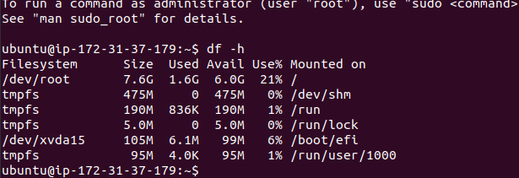
Here you can see dev/root but the device name of our attached volume is dev/sdf

>>

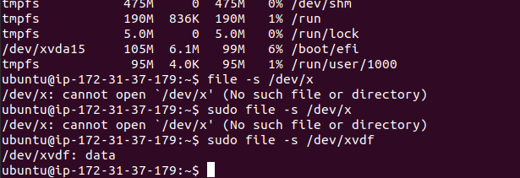
if it shows :data i.e., it is not formatted
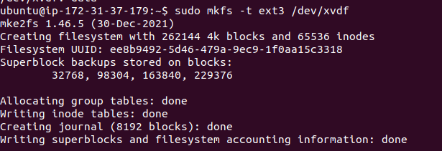
now the data will be formatted
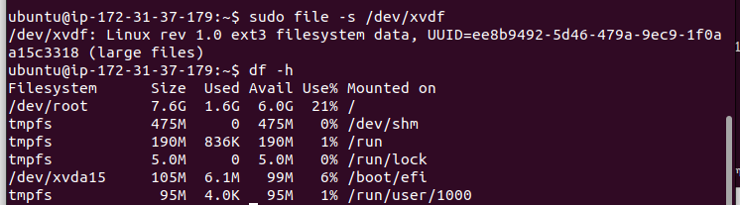
Now, mount to particular folder
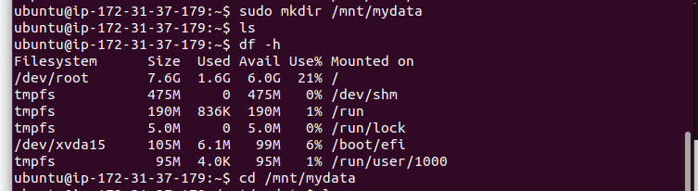
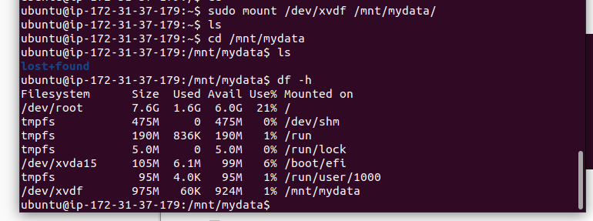
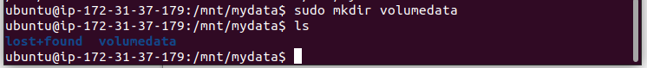
>>cd volumedata
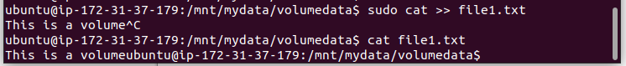
Now take snapshot of the volume

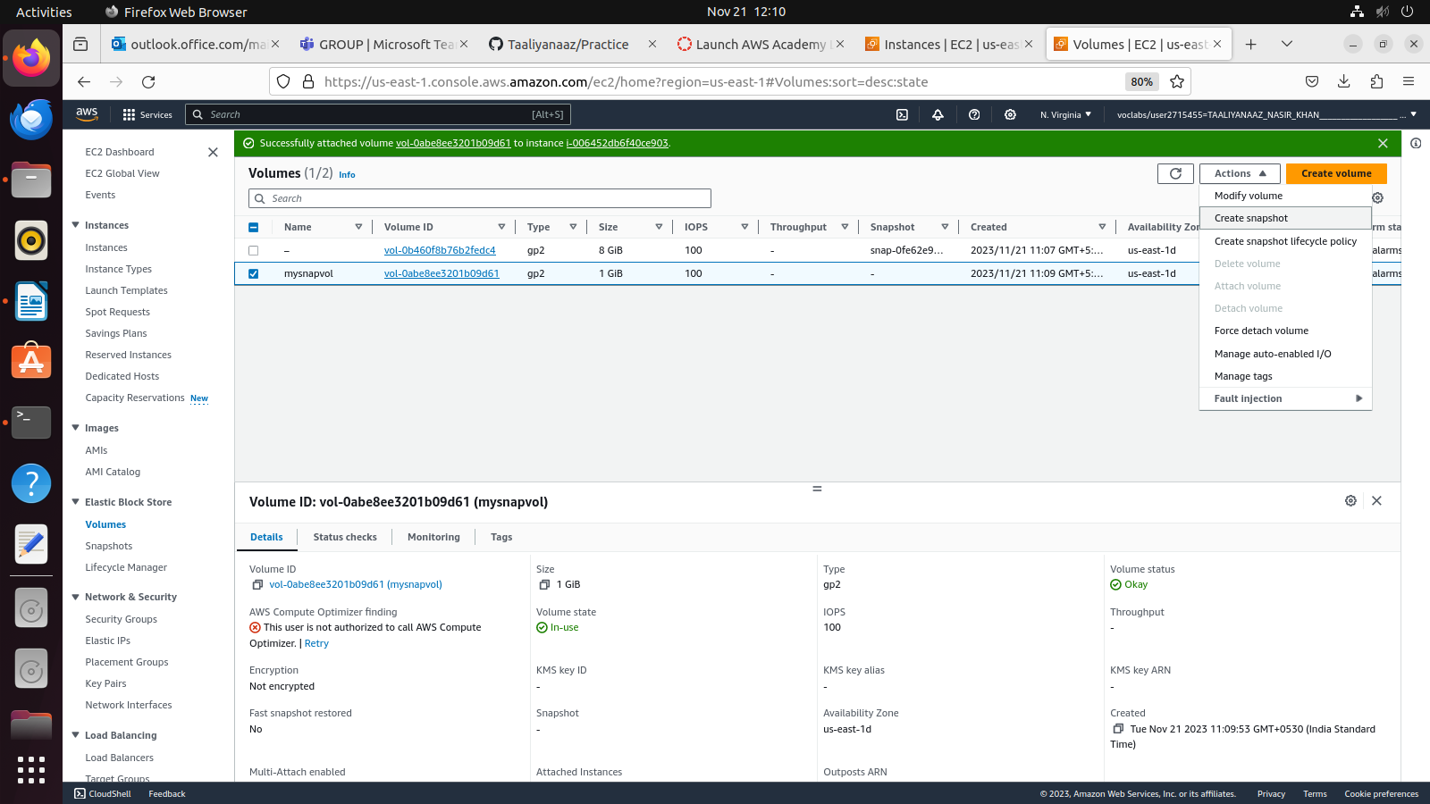
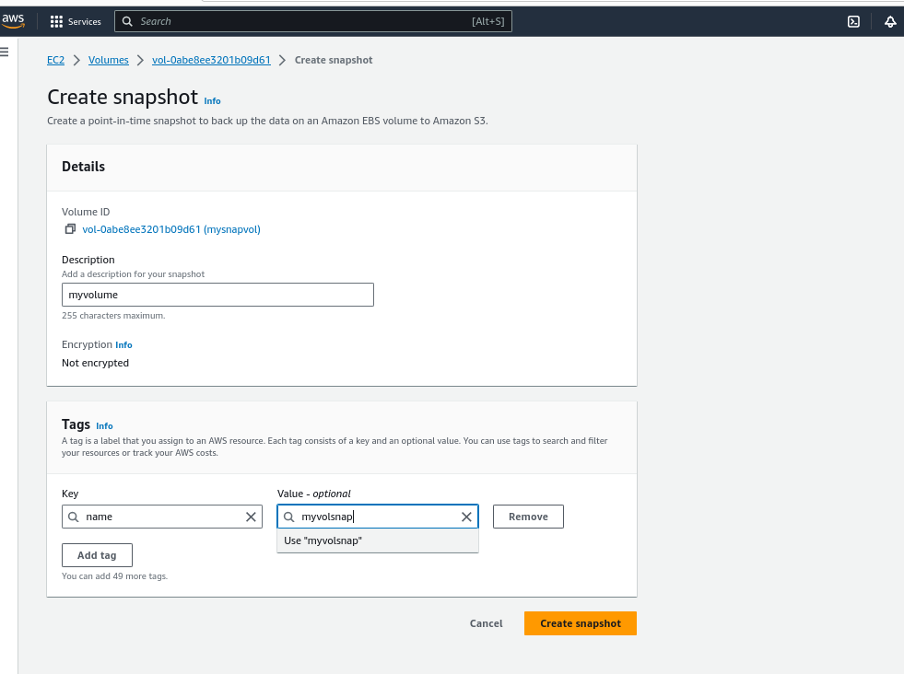
create snapshot
Go to snapshot from the left hand navigation
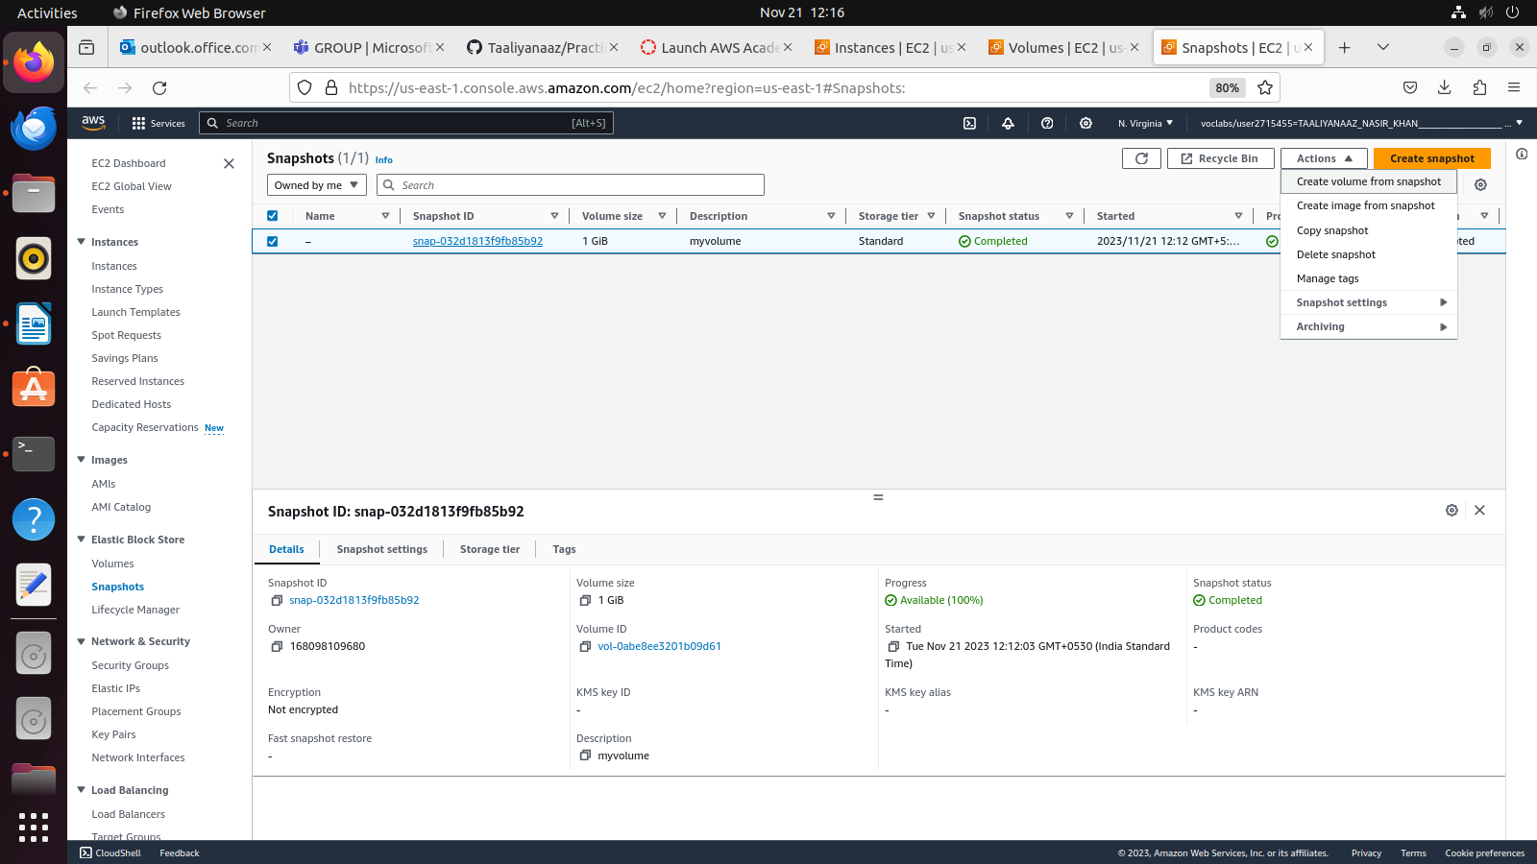
Keep everything default but add tag

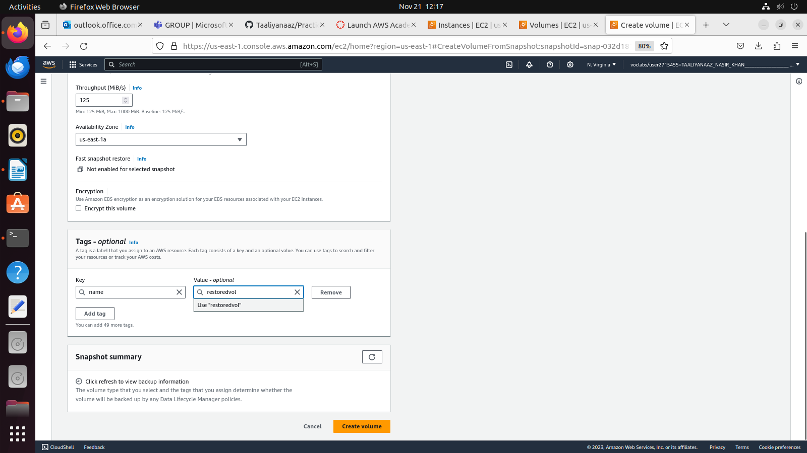
Click on create volume

Once this volume is created, Attach the volume
Volume > Action > attach volume

In the same ssh’ed instance
.. sudo file -s /dev/xvdf
